Olufemi Odedeyi
GLA DATA 1 2022
Assignment 1 dATA VISUALIZATION

Contents
Task 1……………………………………………………………………………………………………………………………….1 page
Task 2…………………………………………………………………………………………………………………………………8 Pages
Task 3…………………………………………………………………………………………………………………………………1 Page

Task 1

Copyright, Design, and patents Act 1988
It gives the creator or author the exclusive right to copy, communicate, lend or sell copies of the work.

Data Protection Acts (1998, 2018)
The Data Protection Act (2018) sets out the guidelines for data protection law in the UK. It updates and replaces the Data protection Act 1998 and came into effect on 25th May 2018.
It was amended on 01 January 2021 by regulations under the European union (withdrawal) Act 2018, to reflect the UK’S Status outside the EU, The Data protection Act 2018 controls how your personal information is used by organisations, businesses, or the government.

Task 2

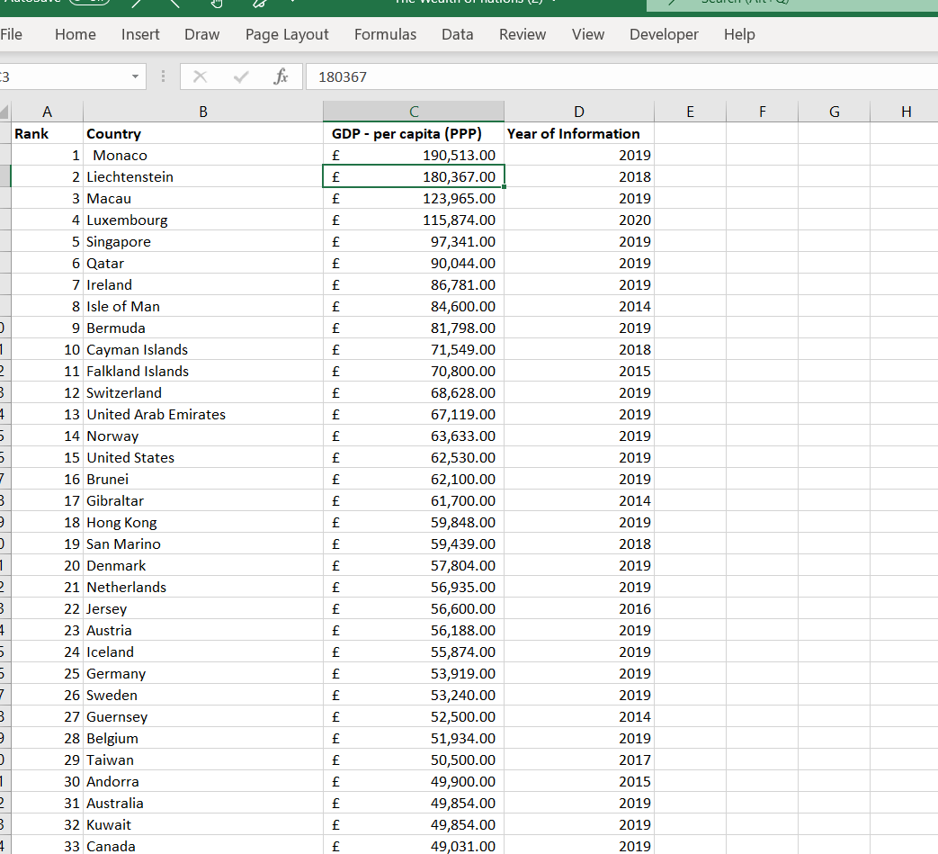

I Downloaded the dataset to a desktop version.

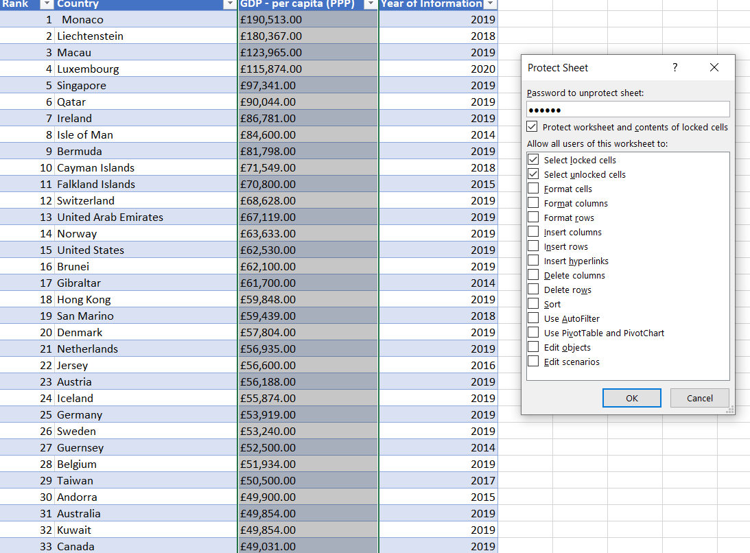

Password Created to protect unauthorized person to adjust data.

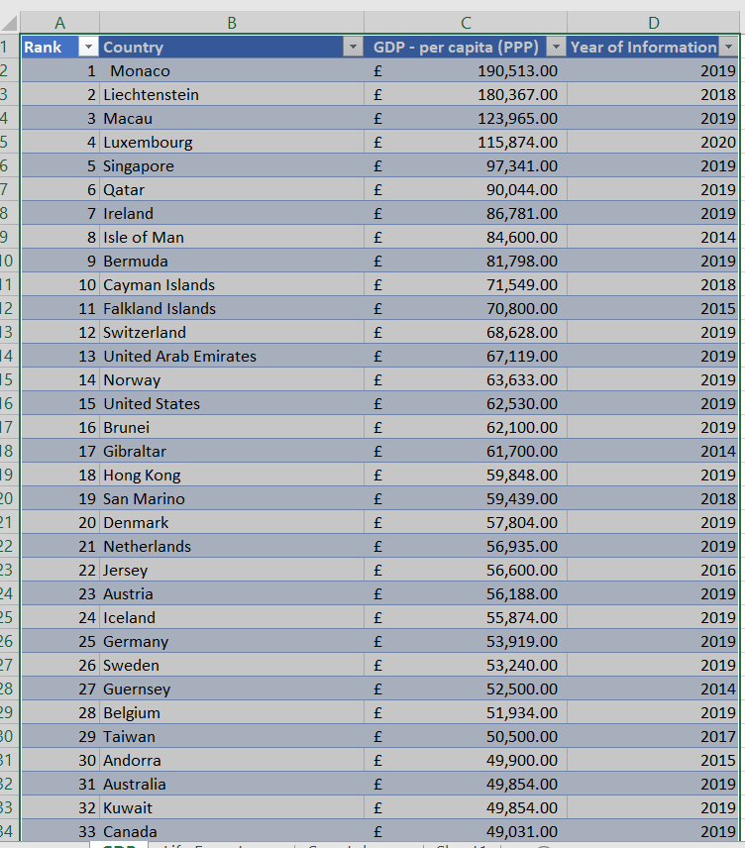

Click on any display number or word from the data and press ctrl T to formulate a table

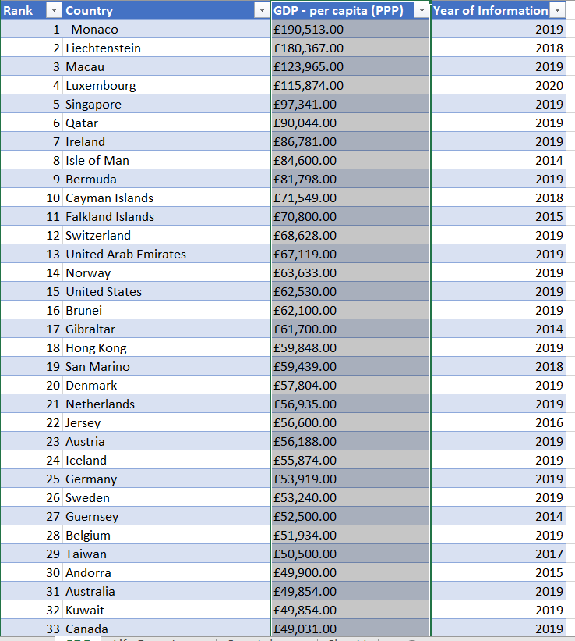

Highlight column C and click on home to locate General and change general to currency, the column C will be changed or configured to currency

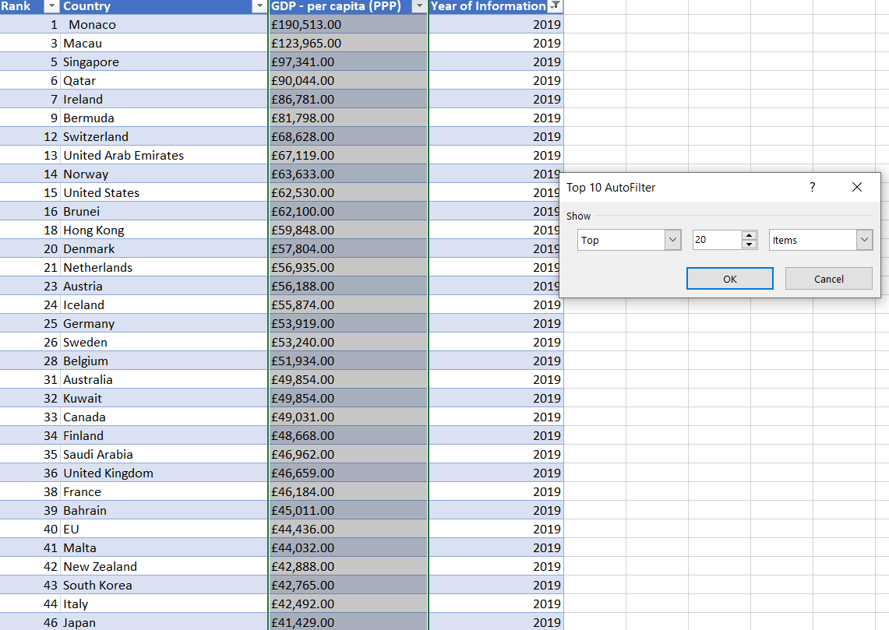

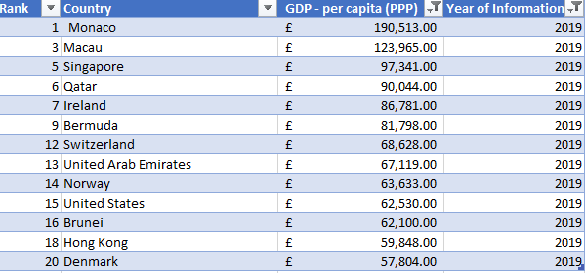

Top 20 highest ranking counties

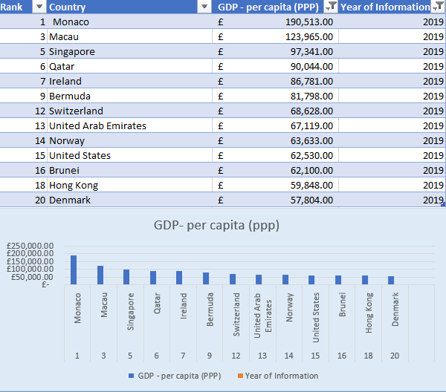

Top 20 countries and a chart to display their rankings.

I highlighted the entire top 20 table and clicked on insert on the table to pick up chart design to use.

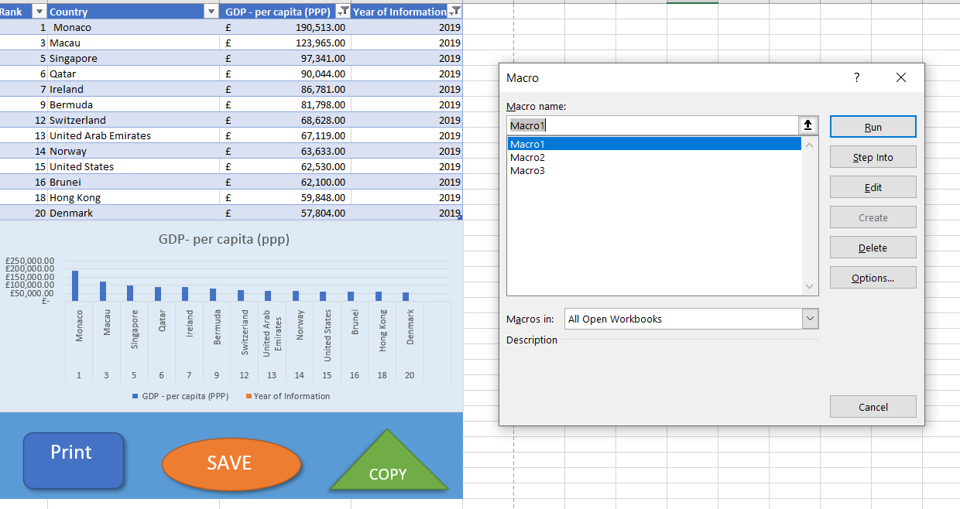

Top 20 countries and a chart to display their rankings and a macro system.

Task 3

Click on this link below for my Tableau Dashboard
Top 20 Countries Version 2 | Tableau Public

